INFOSYS SPRINGBOARD
NARRATIVE FLOW
Story Co-Writer
INKFORGE
Phase 1 — UI & Streamlit Documentation
Submitted by: Subasri B
Infosys Springboard Project

AI-Powered Fiction Writing · Local LLM · Streamlit Web App

1. Project Overview
INKFORGE is an AI-powered story co-writing web application developed as part of the Infosys Springboard programme. It enables writers to collaborate with a local AI model (Ollama) to craft, develop, and publish fictional narratives across multiple genres. The application is fully local — no data leaves the user's machine — making it private, fast, and cost-free to run.

The Phase 1 deliverable covers the complete user interface implementation using Streamlit as the application framework, along with all supporting UI components, styling, and user experience design decisions.

Project Goals
- Provide an immersive, distraction-free writing environment
- Enable real-time AI story co-authorship with a local LLM
- Offer professional-grade book export (PDF, TXT)
- Support per-user accounts with persistent story history
- Deliver a polished, publication-inspired visual aesthetic

Key Statistics
Metric | Value
Application Type | Streamlit Web Application (Python)
UI Framework | Streamlit + Custom HTML/CSS/JS Components
AI Backend | Ollama (Local LLM — llama3 and compatible models)
Authentication | Local user accounts with SHA-256 password hashing
Export Formats | PDF (A5 print-ready) · Plain Text (.txt)
Story Genres | 8 genres — Fantasy, Sci-Fi, Thriller, Romance, Horror, Mystery, Historical, Literary
Writing Tools | Forge, Workshop, Story Vault, Story Compass — 4 core modules

2. Technology Stack
INKFORGE Phase 1 is built entirely in Python with Streamlit as the web framework. The UI is enhanced with custom HTML, CSS, and JavaScript injected through Streamlit's component system to achieve a level of visual polish beyond what native Streamlit widgets provide.

Layer | Technology | Purpose
Web Framework | Streamlit 1.x | Page layout, state management, widget rendering, user interactions
Styling | Custom CSS (injected) | Typography, colour scheme, animations, responsive layout
Dynamic UI | Custom JS (via components.html) | Ink particle effects, sidebar toggle, book viewer interactivity
AI Engine | Ollama (REST API) | Local LLM inference — story generation, title extraction, character detection
PDF Export | ReportLab | A5 print-ready PDF generation with custom fonts, drop caps, chapter headers
Authentication | Python (hashlib, secrets) | SHA-256 password hashing, session tokens, per-user JSON data stores
Font System | Google Fonts (CDN) | Playfair Display, Crimson Pro, Cormorant Garamond, Space Mono

Why Streamlit?
Streamlit was chosen for Phase 1 because it allows rapid prototyping of data and AI applications in pure Python, with a built-in reactive state model. Its component system allows raw HTML/CSS/JS to be injected when needed, giving full control over visual presentation while keeping all business logic in Python.

Streamlit Key Features Used in INKFORGE:
• st.session_state — Persistent per-session story data, auth tokens, UI state
• st.columns / st.container — Three-panel layout (Actions | Story Feed | Right Panel)
• st.sidebar — Story history, user profile, search, navigation
• streamlit.components.v1 — Custom HTML book viewer, ink particle canvas, sidebar JS
• st.form / st.form_submit_button — Inline story rename with Enter-key support
• st.download_button — PDF and TXT export directly from the browser

3. Application Layout & Navigation
INKFORGE uses a three-column layout within Streamlit's main content area, combined with a persistent left sidebar for story history and user management. A custom top navigation bar displays the brand, active story metadata, writing progress, and tab navigation.

Layout Structure
Area | Description
Top Navigation Bar | Brand mark (I), story genre/tone/POV pills, daily word count progress, total word count
Tab Bar | Four tabs — The Forge · Workshop · Story Vault · Story Compass
Left Sidebar | User profile, New Story button, search, story history cards, Sign Out
Left Panel (Forge) | Action buttons (Continue, Enhance, Rewrite, etc.), Scene Mood radio, Daily Goal tracker
Centre Panel (Forge) | Your Manuscript (book viewer), Story Feed (passage cards), Write Zone input
Right Panel (Forge) | Characters field, World/Context field, Author Fixes buttons, Statistics grid

Tab Modules
- The Forge — The primary writing workspace. Houses the book viewer, story feed, and all AI generation controls.
- Workshop — Six professional writing tools: Character Forge, World Architect, Plot Architect, Dialogue Coach, Prose Doctor, Story Analyst.
- Story Vault — Manuscript preview, full story export (.txt), book-only export, chapter management.
- Story Compass — Guided writing coach with custom questions and eight quick-craft shortcuts.

Sidebar — Story History
The sidebar contains a full story history system with search, pinning, archiving, renaming, and deletion. Each story card shows the title, genre, word count, and last updated date. An inline contextual menu (⋯ button) reveals story management actions. The sidebar can be toggled open or closed via a custom pill button fixed to the left edge of the screen.

4. Visual Design System
The visual design of INKFORGE is inspired by the aesthetic of printed books and traditional publishing — cream pages, ink-dark typography, and gold accents. Every UI element is styled to evoke the feeling of a premium writing studio.

Colour Palette
Colour | Usage
#111008 (Ink Black) | Primary text, button hover states, borders, brand elements
#F7F4EE (Cream) | Sidebar background, card backgrounds, page backgrounds
#B8860B (Dark Gold) | Accents, active states, forge button hover, book chapter rules, gold highlights
#C5BDB0 (Ruled) | Dividers, card borders, page lines, inactive UI elements
#8A8470 (Ink 4) | Secondary text, metadata labels, timestamps, captions
#FFFFFF (White) | Main content area background, input fields, button default states

Typography
Font | Role
Playfair Display | Brand name, section titles, large display headings — serif, editorial weight
Crimson Pro | Body copy, story passages, paragraph text — elegant readable serif
Cormorant Garamond | Story card titles in sidebar — refined, literary character
Space Mono | Labels, metadata, badges, button text — monospace for precision and contrast

Design Principles
- Ink & Paper — The entire palette is derived from physical print: cream stock, ink black, gold foil accents.
- Typography-First — Four carefully chosen typefaces cover every layer of hierarchy without visual clutter.
- Minimal Chrome — Navigation is restrained; the writing surface is always the visual focus.
- Inversion on Hover — Buttons flip from white-on-dark-border to white-text-on-black to signal interactivity clearly.
- Micro-animations — Ink particle canvas follows the cursor; page transitions in the book viewer use smooth fade.

5. The Forge — Main Writing Workspace
The Forge is the heart of INKFORGE. It is a full-screen three-panel writing environment where all AI story generation takes place. The user types directions in the Write Zone, chooses an action, and the AI generates story prose in real time.

Write Zone
A large text area at the bottom of the centre panel accepts free-form writing directions. The FORGE button (tall, dark, prominent) sits beside it. During generation, passages stream live into a preview box above the feed, giving real-time visual feedback of the AI writing.

Action Buttons (Left Panel)
Ten action buttons allow the writer to direct the AI with precision: Continue, Enhance, Rewrite, Plot Twist, Dialogue, Describe, Foreshadow, Raise Stakes, Flashback, and End Chapter. Each triggers a specialised system prompt that shapes the AI's output accordingly.

Story Feed
Each AI-generated passage appears as a collapsible card in the Story Feed. Cards display the action type badge, genre, timestamp, and word count. Passages can be expanded to read in full and include an Edit Before Adding to Book inline editor. The latest passage is always expanded by default.

Right Panel — Characters & World
Writers type their characters and world context directly into text areas. The AI uses this information alongside genre, tone, and mood for every subsequent passage. Fields are auto-populated by the AI after the first passage if left empty, and display AUTO or SET badges to indicate their state. A CLEAR button is available to reset each field independently.

6. The Book Viewer
The Book Viewer is a custom HTML component embedded in the Forge tab. It presents selected story passages as a dual-page open book spread — faithfully replicating the visual experience of reading a physical book. Passages must be added to the book using the + ADD TO BOOK button before they appear in the viewer.

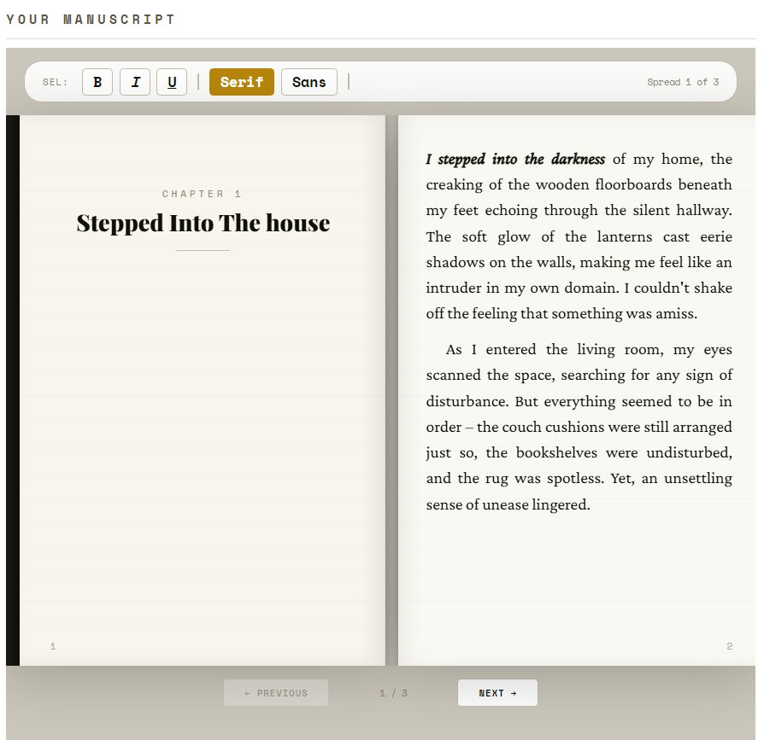
Figure 1 — The dual-page open book viewer with chapter title and formatted story text

Book Viewer Features
Feature | Description
Dual-page spread | Left and right pages rendered side by side with a realistic spine and gutter shadow
Pagination | Passages are automatically paginated to 16 lines per page; chapter titles always open on the left
Formatting toolbar | Bold (B), Italic (I), Underline (U) buttons for text selection; Serif / Sans font toggle
Page navigation | Previous / Next spread navigation with smooth fade transitions
Page numbers | Alternating left/right page numbers as in a real book
Line texture | Faint ruled-line background on each page evokes physical paper

Book Actions
Below the viewer, three action buttons are available when the book has content: Download Book (generates an A5 print-ready PDF), New Chapter (inserts a chapter break), and Clear Book (removes all passages from the book without deleting the story). The Download Book PDF includes the cover page, chapter headers, drop caps, and alternating page numbers.

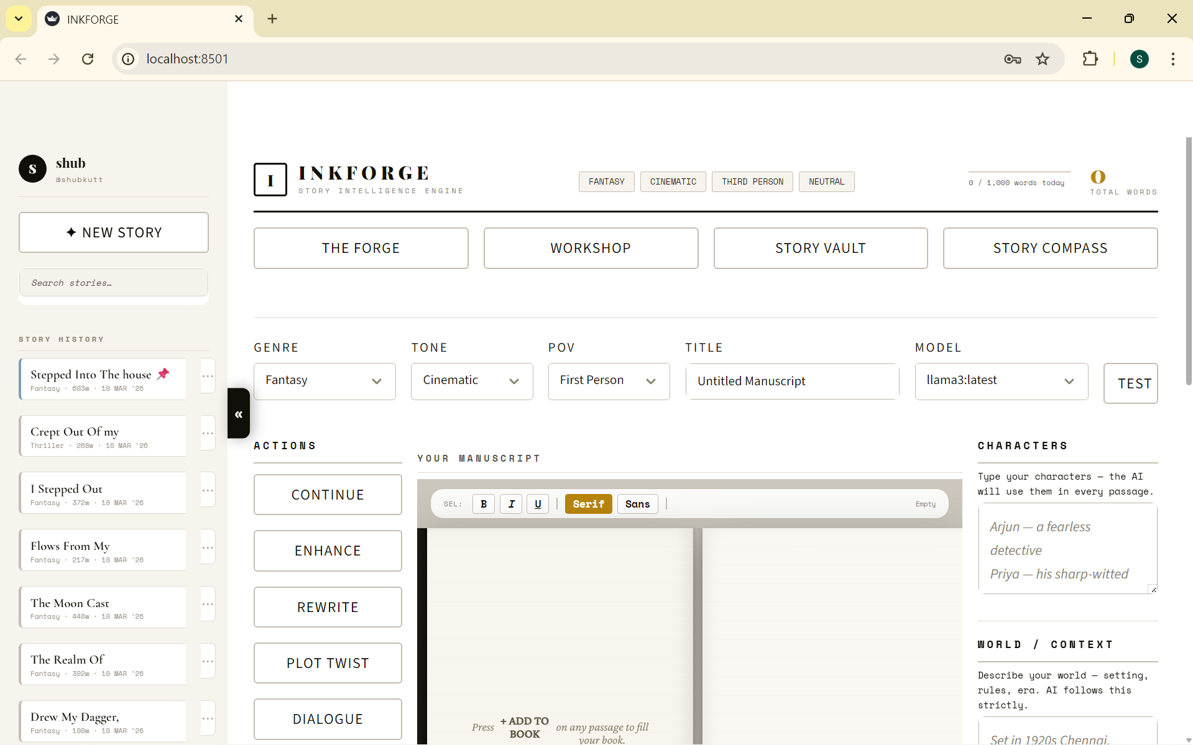

7. Story History & User Management

Authentication
INKFORGE includes a full local authentication system. New users register with a display name, username, and password (minimum 6 characters). Passwords are hashed with SHA-256 before storage — never stored in plain text. Session tokens are generated with Python's secrets module and stored server-side. A Google OAuth placeholder is included in the Sign In screen for future integration.

Story History Sidebar
Every story session is automatically saved to the user's personal history after each AI generation. The sidebar displays up to 50 stories, sorted with pinned stories first and then by most recently updated. A search bar filters by title or genre. Each card shows the story title, genre, word count, and formatted date.

Story Card Management
Clicking the ⋯ button on any story card opens an inline contextual menu with five actions:
- Share — Generates a shareable link (localhost URL with token) and displays it inline
- Rename — Opens an inline form with a text input pre-filled with the current title; Save and Cancel buttons sit side by side
- Pin story / Unpin story — Pinned stories float to the top of the history list with a blue left border
- Archive / Unarchive — Archived stories move to a separate Archived section at the bottom of the sidebar
- Delete — Permanently removes the story from history

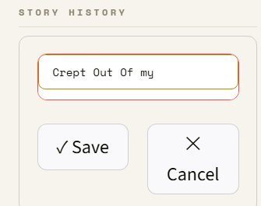
Figure 2 — Inline rename form with Save and Cancel buttons in the Story History sidebar

8. Workshop & Story Compass

The Author's Workshop
The Workshop tab provides six professional writing tools, each in its own card. All tools send queries through the same guardrail-protected AI pipeline that keeps Ollama focused on story-related content only.

Tool | Description
Character Forge | Generates a deep psychological character profile — backstory, motivation, fear, secret, contradiction, and speech pattern — from a name, role, and trait input.
World Architect | Builds a full world bible for a chosen world type and concept — power systems, social structure, locations, and history.
Plot Architect | Generates a structured story outline using one of five narrative frameworks: Three Act, Hero's Journey, Save the Cat, Five Act, or Kishōtenketsu.
Dialogue Coach | Rewrites pasted dialogue with subtext — characters never say exactly what they mean.
Prose Doctor | Diagnoses weaknesses in a pasted passage then rewrites it as a master author would.
Story Analyst | Provides editorial feedback on a pasted excerpt, focused on one of five areas: Overall Quality, Pacing, Voice, Show vs Tell, or Tension.

The Story Compass
The Story Compass is a personal writing coach module. Writers type a free-form question about their story or craft, and receive detailed guidance tailored to their active genre. Eight Quick Craft shortcut buttons provide instant access to common coaching topics: I Am Stuck, Pacing Guide, Subtext, Show Don't Tell, Write a Villain, Hook Endings, Opening Lines, and Raise Tension.

Workshop Output
All workshop and compass results appear in a styled output panel below the tools. Two action buttons — Add to Context (pushes the result into the world context field for the AI to use) and Clear — allow the writer to act on the output immediately. Results persist across tab switches within the same session.

9. Phase 1 Summary

Delivered Features
- Full Streamlit web application with login, registration, and session management
- Three-panel responsive layout with persistent sidebar navigation
- Custom CSS design system — ink/cream/gold palette, four-font hierarchy, micro-animations
- AI story generation with streaming output, 10 action types, 8 genres, 6 tones
- Dual-page open book viewer with pagination, formatting toolbar, and page navigation
- A5 print-ready PDF export via ReportLab with cover, chapter headers, and drop caps
- Six-tool Author's Workshop and Story Compass coaching module
- Per-user story history with search, pin, archive, rename, delete, and share
- Auto-extraction of characters and world context from generated prose
- Ink particle cursor effect and collapsible sidebar with custom toggle pill

Technical Highlights
- All styling delivered through injected CSS — no external UI framework dependency
- Custom JS components bypass Streamlit's iframe sandbox using window.parent DOM access
- ReportLab PDF pipeline with platform-aware font loading (Windows / macOS / Linux)
- Guardrail system in StoryEngine prevents Ollama from answering non-story queries
- SHA-256 authentication with secrets-module token generation — no third-party auth library

Phase 2 — Planned Scope
- Google OAuth integration (placeholder already in UI)
- Real-time formatting persistence from book viewer to PDF export
- Cloud deployment and shared story hosting
- Collaborative writing mode — multiple users on one story
- Advanced AI model selection and fine-tuning support

Phase 1 Status: COMPLETE
Submitted by: Subasri B
Project: Narrative Flow Story Co-Writer — INKFORGE
Programme: Infosys Springboard
Framework: Streamlit + Python + Ollama (Local LLM)

